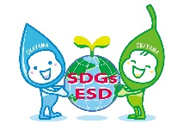
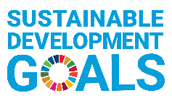
Okayama ESD Award 2023
－ Application Form －

※In the column with a word limit, please indicate the number of words you have written. Points may be deducted for exceeding the word limit.
※Please keep the data size of one e-mail to 8MB or less.
※Google Drive and password-protected compressed files are not acceptable.

- Information about Your Organization <Required>
(Please use extra space if needed.)
Name of Organization (For universities, please include the name of the department)
Name of Representative of Organization
Street Address of Headquarters  (including Postal Code) |  | Country
Telephone Number
URLs of Website/ Facebook
Contact Person | [Name/ Title/ Department]
Email Address of Contact Person
Category of Organization | Please check one category that best describes your organization.
☐ School, University
☐ NGO, Civic Group
☐ Local Group, Community Learning Centre (CLC)
☐ Others (Please specify: )
Description of Organization | Please provide a summary description of your organization. 【max. 150 words】
 | [Word counts: ( ) words]

- Information of Your Project <Required>

- Name
of Project
- Description  of Project | Please provide clear overview of your project. 【max. 300 words】
 | [Word counts: ( ) words]
 | Please write the URL of the project’s website if there is one.
- Basic Information | Duration | Started in (month/year) | ( / ) ※The project should be ongoing and have been running for at least two years as of April 2023. (The start day must be before March 2021.)
 |  | If this project will continue in the future, please check the “Continue” checkbox, and if you have a definite plan to terminate the project, please write the termination date (month/ year). | Continue ☐  Termination Date ( / )
 | Target group(s) | Target area(s)
 |  | Target group(s)
 |  | Number of targeted people | about ( ) persons
 | Annual cost | Annual cost of the project | about ( ) US Dollars/ per year
 | Funding source(s) | Please explain the funding source(s) of the project, such as subsidies, donations, public funds, etc.
- Vision | Please describe the following two points in details: 【max. 300 words】  ・Goals of the project including target values  ・Challenges faced by local communities in achieving a sustainable society
 | [Word counts: ( ) words]
- Collaboration | Please describe in detail the implementation system, including the structure of the collaborating groups and organizations and the rolls of each entity, in words. If you would like to paste diagrams, the resolution must be legible. 【max. 400 words; including text if using figures and tables, no more than 2 pages】
 | [Word counts: ( ) words]
- Integration | Please describe how the project integrates economic, environmental, and social dimensions of sustainable development. 【max. 200 words】
 | [Word counts: ( ) words]
- Innovation | Please describe how the project demonstrates innovative approaches and method to ESD. 【max. 200 words】
 | [Word counts: ( ) words]
- Status of Implementation | Please describe the following two points in detail: 【max. 300 words】  ・Quantitative data such as the total number of project participants and organizations, results of participant surveys, etc.  ・Objective evaluation such as feedback from participant questionnaires, articles and news coverage, and awards received to date
 | [Word counts: ( ) words]

- Empowerment | - Please describe the kinds of educational approaches that the project is using in detail, such as interactive learning for problem-solving and/or participatory practices. 【max. 400 words】
 | [Word counts: ( ) words]
- Please describe achievements of the project and ways to disseminate the results in detail, such as how the project brought behavior change among the targeted groups including the transformation of values, attitudes and actions, and empowered local communities.
【max. 400 words】
 | [Word counts: ( ) words]
- Future Strategy | Please describe how you are planning to develop and expand the project in the future. Please also include detailed information such as any strategies, expected target groups, expected project duration and budgets per year. 【max. 200 words】
 | [Word counts: ( ) words]

- Contribution to the Sustainable Development Goals (SDGs)※ <Required>
To which SDG goal(s) is (are) the submitted project related?
※Please refer to the United Nations website about the SDGs. (http://www.un.org/sustainabledevelopment/)

- Please check all SDG goals related to the submitted project. (Multiple answers allowed.)
☐ 1 No Poverty  ☐ 2 Zero Hunger  ☐ 3 Good Health and Well-Being  ☐ 4 Quality Educationon  ☐ 5 Gender Equality  ☐ 6 Clean Water and Sanitation  ☐ 7 Affordable and Clean Energy  ☐ 8 Decent Work and Economic Growth  ☐ 9 Industry, Innovation and Infrastructure | ☐ 10 Reduced Inequalities  ☐ 11 Sustainable Cities and Communities  ☐ 12 Responsible Consumption and Production  ☐ 13 Climate Action  ☐ 14 Life below Water  ☐ 15 Life on Land  ☐ 16 Peace, Justice and strong Institutions  ☐ 17 Partnerships for the Goals
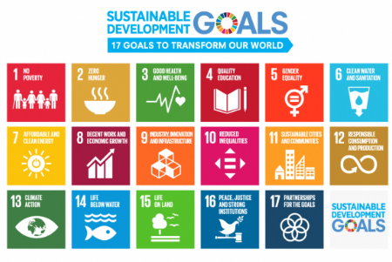
- Which SDG goal is most relevant to the submitted project? (Select One)
- Please describe how the submitted project relates to one or more of the SDGs. 【max. 200 words】
[Word counts: ( ) words]

- A Video / Slideshow or Photos as an Alternative to Introduce the Project <Required>
Please make one video or slideshow of the project (5 minutes or less), upload it on YouTube or Facebook, and write its URL in the box below.
※Please do NOT directly send the data by e-mail.

If you have difficulty to make a video or slideshow, you can submit photos (5 to 10) by email instead.

URL of a Video or a Slideshow | Please provide only one URL where the data has been uploaded below.

- Other Supporting Documents <Optional>
You can submit relevant supporting documents (total 5 pages or less in A4 Size) by email, and list the titles below.

1.
2.
3.

