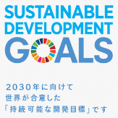
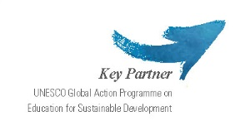
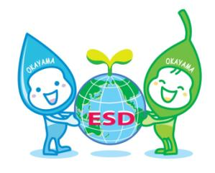
Okayama ESD Award 2020
－ Application Form －

Please ensure that the words do not exceed the limitation.
In the case word counts exceeds the limitation, demerit marks may be given.
(Please fill out the word counts in the column.)

- Information about your organization
(Please use extra space if needed.)
Name of Organization
Name of Representative/
Affiliation
Contact person/  Affiliation | [Name/ Title/ Department]
Postal address |  | Country
Telephone
Fax
Email address
Website
Category of Organization | Please tick one category that best describes your organization.
School, University
NGO, Civic Group
Local Group, Community Learning Center (CLC)
Others (Please specify: )
Description of Organization | Please provide a summary description of your organization in a maximum of 150 words.
 | [Word counts: ( ) words]

- Information of your project

- Name
of project
- Description  of Project | Please give an overview of your project including the objective and implementation method in a maximum of 150 words.
 | [Word counts: ( ) words]
 | Please write the URL of the project’s website.
- Basic Information | Duration | Started in | month/year ※It should have started before March 2018.
 |  | Ended in | month/year
 | Target group(s) | Target area(s)
 |  | Target group(s)
 |  | Number of people targeted | about ( ) persons
 | Annual cost | Annual cost of the project | about ( ) US Dollars/ per year
 | Funding source(s) | Please explain the funding source(s) of the project, such as subsidies, donations, public funds, etc.
- Vision | Please describe the issues that local communities are facing in building a sustainable society, as well as objectives and goals of the project with numeral targets in Max. 150 words.
 | [Word counts: ( ) words]
- Collaboration | Please describe an implementation structure (ex. Diagram) illustrating the roles of collaborating organizations in detail.
- Integration | Please describe how the project integrates environmental, social, and economic dimensions of Sustainable Development, in Max. 200 words.
 | [Word counts: ( ) words]
- Empowerment | - Please describe the kinds of educational approaches that the project is using in detail, such as interactive learning for problem-solving and/or participatory practices, in Max. 200 words.
 | [Word counts: ( ) words]
 | - Please describe achievements of the project in detail, such as how the project brought behavior change among the targeted groups including the transformation of values, attitudes and actions, and empowered local communities in Max. 200 Words.
 | [Word counts: ( ) words]
- Innovation | Please describe how the project demonstrates an innovative approach to ESD in Max. 200 words..
 | [Word counts: ( ) words]
- Future Strategy | Please describe how you are planning to develop and expand the project in the future. Please also include detailed information such as any strategies, expected target groups, expected project duration and budgets per year, in max 150 words.
 | [Word counts: ( ) words]

- Contribution to the Sustainable Development Goals (SDGs)※
To which Sustainable Development Goals does the project contribute?
※Please refer to the websites such as that of United Nations about the SDGs. http://www.un.org/sustainabledevelopment/

- Please check one or several goals to which the project contributes.
☐ 1 No Poverty  ☐ 2 Zero Hunger  ☐ 3 Good Health and Well-Being  ☐ 4 Quality Educationon  ☐ 5 Gender Equality  ☐ 6 Clean Water and Sanitation  ☐ 7 Affordable and Clean Energy  ☐ 8 Decent Work and Economic Growth  ☐ 9 Industry, Innovation and Infrastructure | ☐ 10 Reduced Inequalities  ☐ 11 Sustainable Cities and Communities  ☐ 12 Responsible Consumption and Production  ☐ 13 Climate Action  ☐ 14 Life below Water  ☐ 15 Life on Land  ☐ 16 Peace, Justice and Strong Institutions  ☐ 17 Partnerships for the Goals
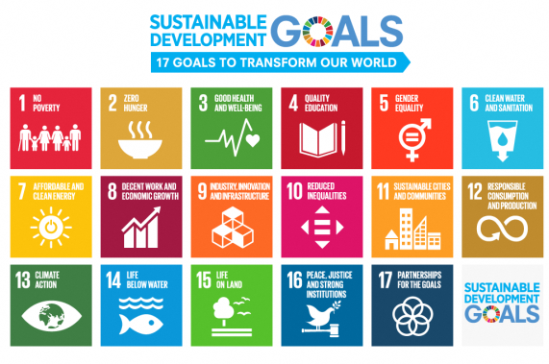
- Please fill out the number of the MAIN goal of the SDGs to which the project mainly contributes.
- Please describe how the project contributes to the implementation of the one or several of the SDGs in Max. 200 words.
[Word counts: ( ) words]

- Movie or Slideshow of the project <Required>
Please prepare a Movie or Slideshow of the project and upload it on YouTube or Vimeo.
※Please note that a Movie or Slideshow cannot be over 5 minutes.
※Please upload the data on ‘YouTube’ or ‘Vimeo’, and write the URL on the column of the Application Form. Please do NOT send the data by e-mail.
※If you have several Movies or Slideshows, please select ONE and give its URL.

URL of a movie or a slideshow | Please provide the URL where the data was uploaded below.

- Other supporting documents <optional>
If you would like to submit any additional supporting documents, please list the titles of the documents below and submit them by email along with your application.
※Please note that documents cannot be more than 5 pages (A4 Paper) in total. Documents exceeding 5 pages will not be accepted or considered.
1.
2.
3.

